**CMSC203 Assignment 4**

Class: CMSC203 CRN [**2**](https://bb-montgomerycollege.blackboard.com/webapps/blackboard/execute/courseMain?course_id=_104851_1)**430**[**7**](https://bb-montgomerycollege.blackboard.com/webapps/blackboard/execute/courseMain?course_id=_104851_1)

 Program: Assignment 0

Instructor: Dr. Tsai

 Summary of Description: (Give a brief description for each Program) A program that simulates a property management company

 Due Date: 10/24/21

 Integrity Pledge: I pledge that I have completed the programming assignment independently.

 I have not copied the code from a student or any source.

Aryan Anwar

**TEST CASES:**

**MANGEMENTCOMPANY TEST**

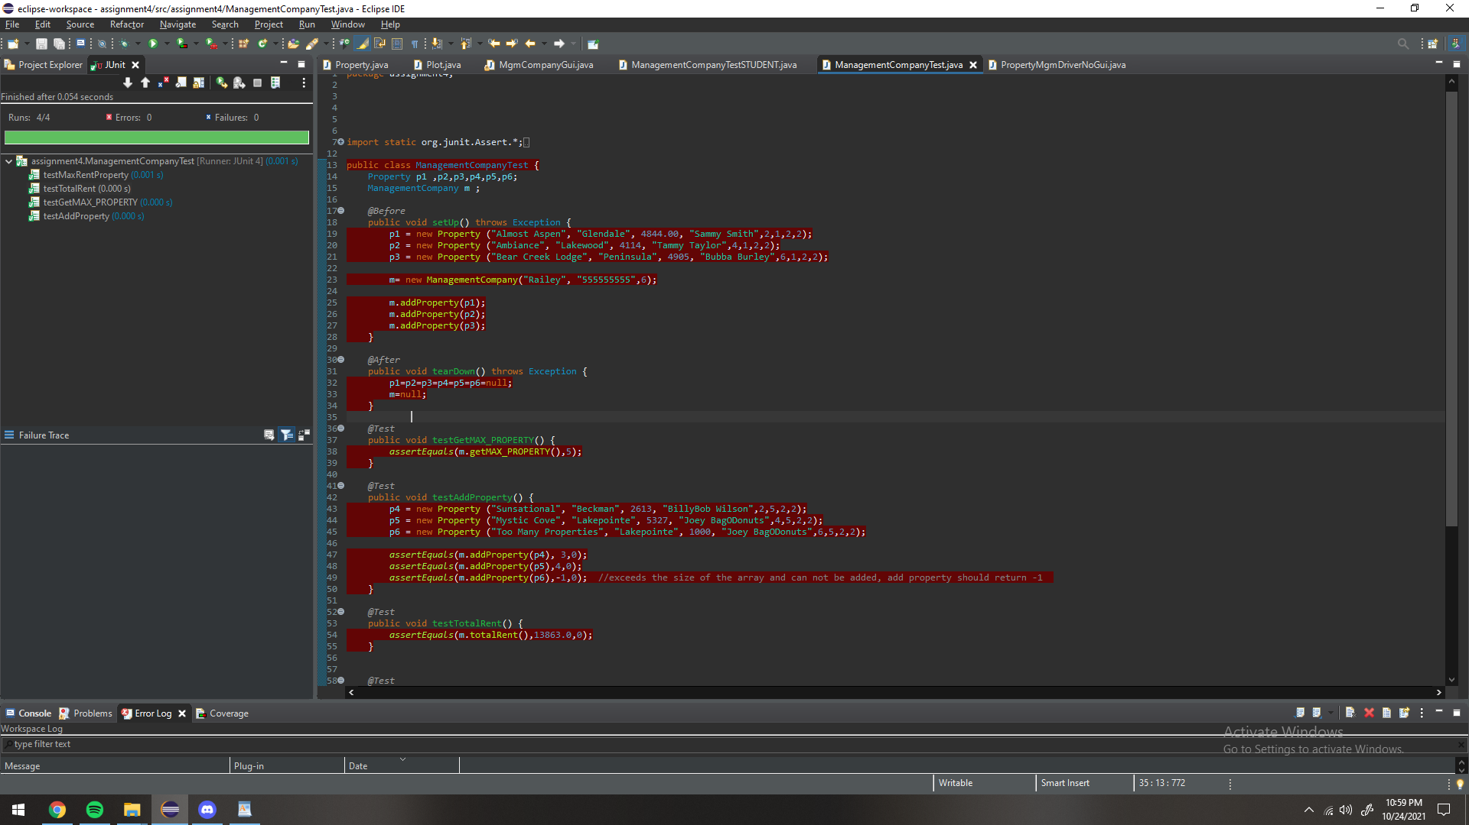

**PLOT TEST**

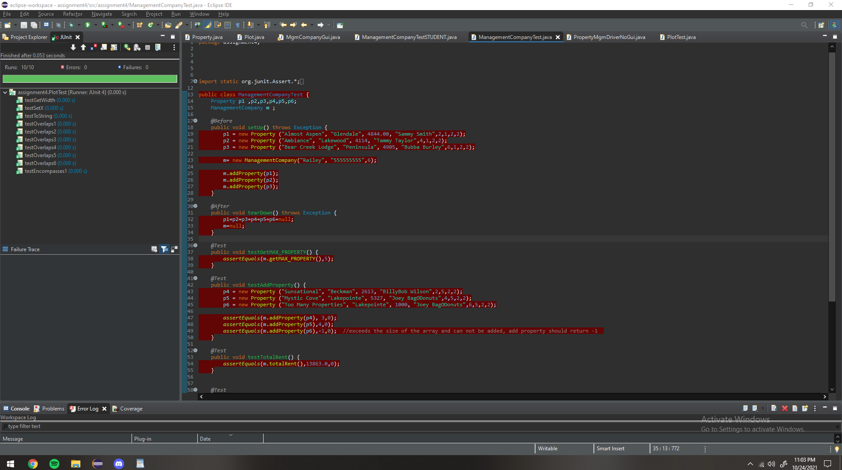

**STUDENT TEST**

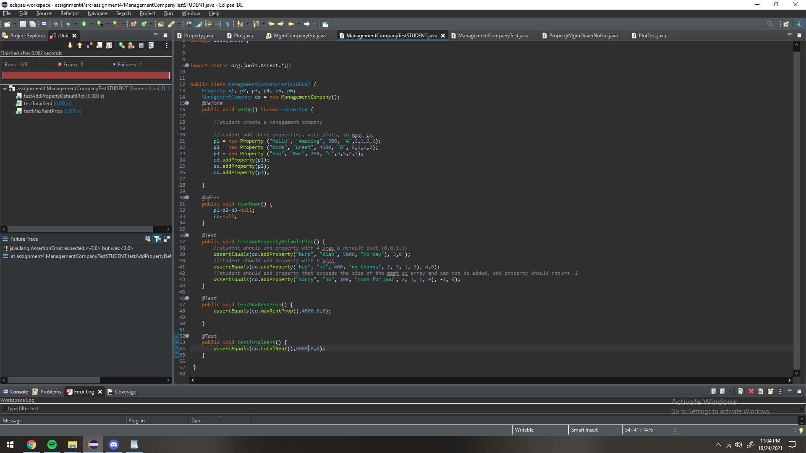

**GUI SCREENSHOT**

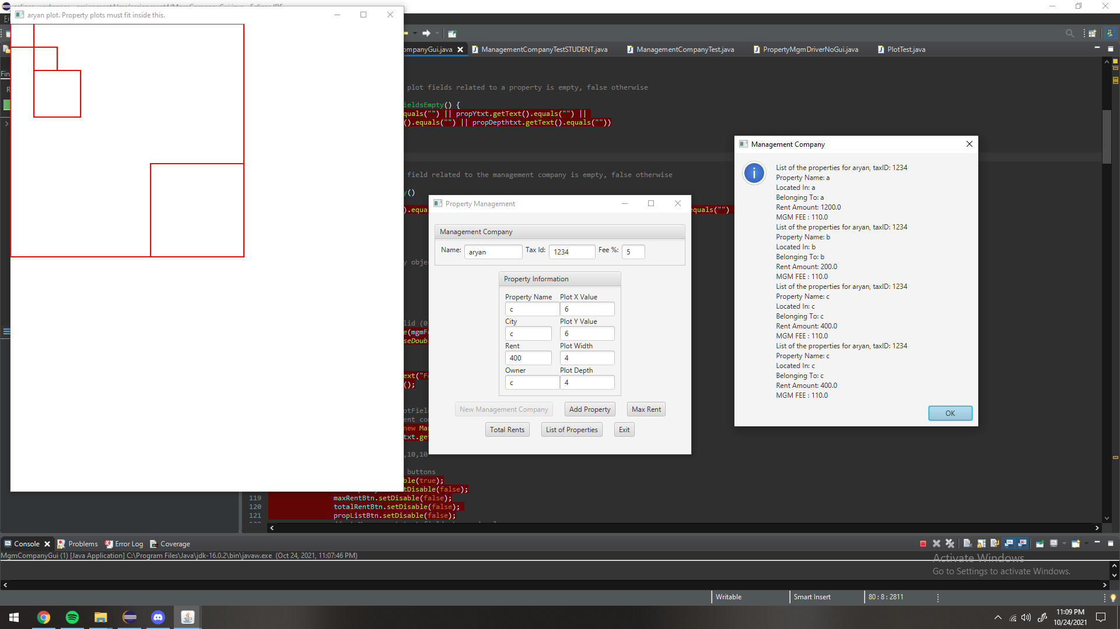

**Lessons Learned:**

Write about your Learning Experience, highlighting your lessons learned and learning experience from working on this assignment.

What have you learned?

I learned how to use OOP and how to use JUnit to test OOP bugs and follow bugs until I find what was wrong.

What did you struggle with?

I struggled with the encompass and overlap functions, I had to draw out diagrams to actually do them.

What parts of this assignment were you successful with, and what parts (if any) were you not successful with?

I was successful with every part of this project.

Provide any additional resources/links/videos you used to while working on this assignment.

**Check List:**

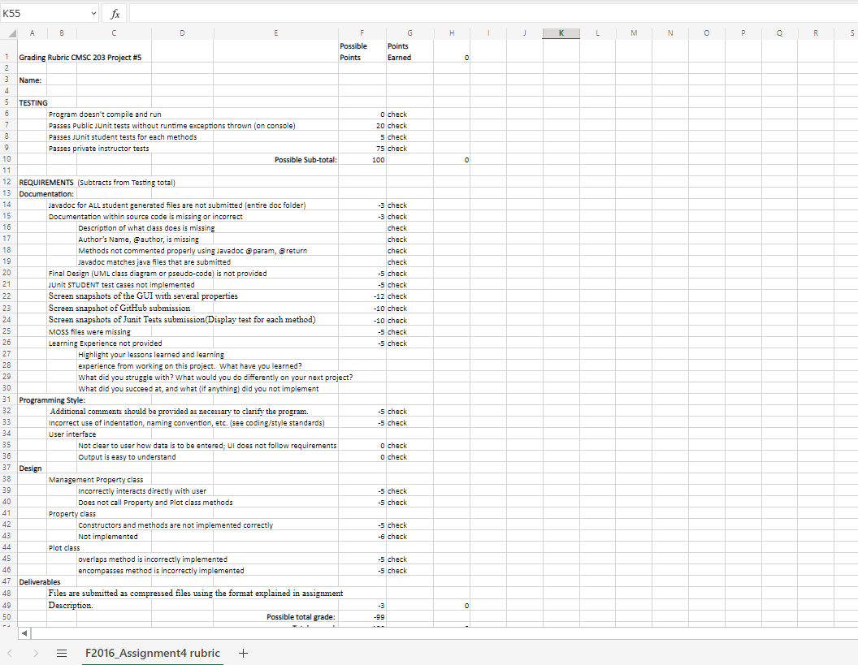

**GITHUB SCREENSHOT:**

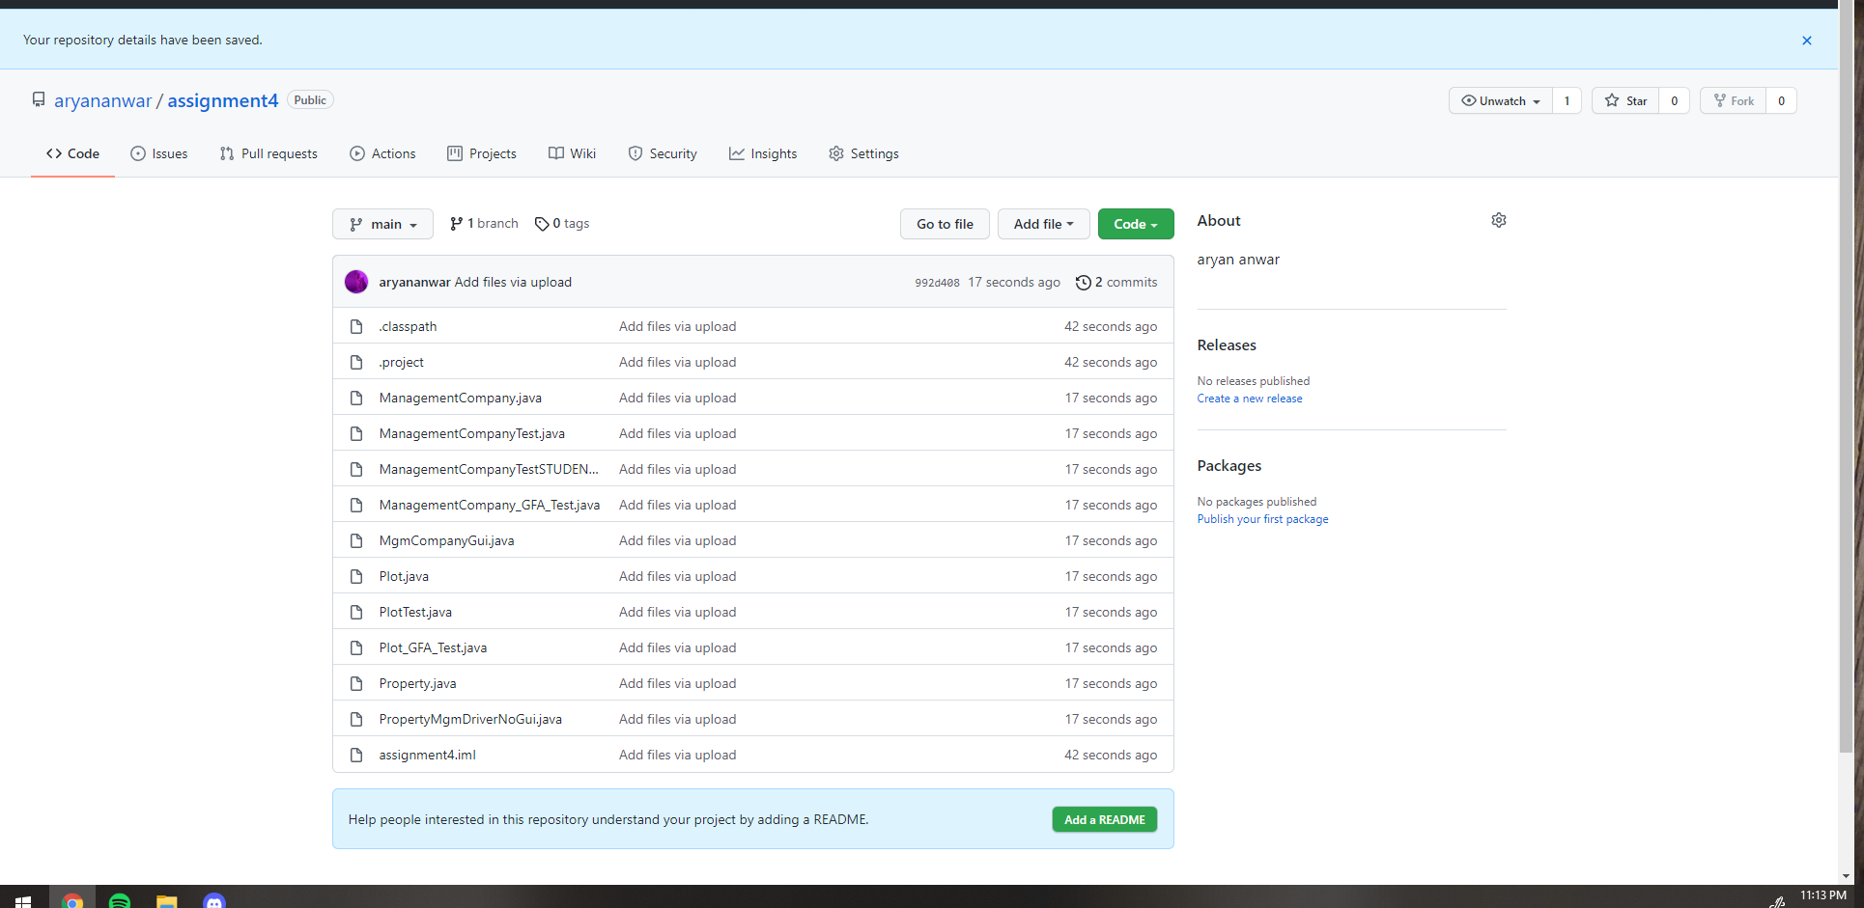

**UML:**

